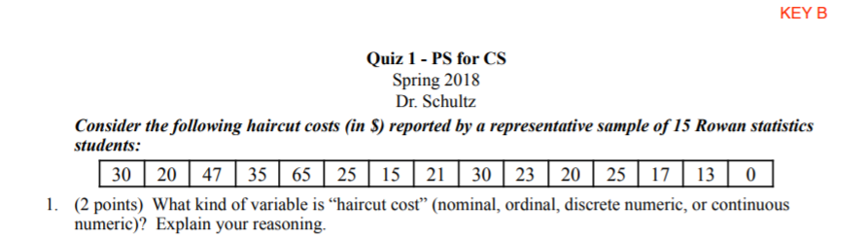



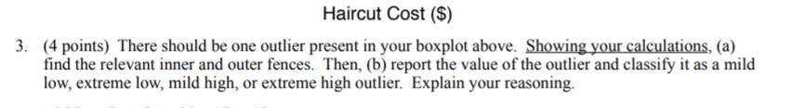



1. Mean
2. Median
3. Standard Deviation